Title

VERITAS DLO AGENT USER GUIDE

Prepared By
Backup Team

Date: 12-07-2019

Version 1.0

Document History

Date | Author | Revision | Description
12-07-2019 | Systems Team | Version 1.0 | Document Creation

Approved By: | Tata Business Support Services Limited
Sudhir Challa | Version 1.0

Distribution List
Name | Department | Company | Rights
Backup Team | Technology – Service Delivery | TBSS | Read and Modify
Sudhir Challa | Technology – Service Delivery | TBSS | Verify and Comment
Ali Hyder | Technology – Service Delivery | TBSS | Full and Approve

Security Classification: CBSL Restricted.

VERITAS DLO is a backup solution for laptops with automated file protection and advanced encryption, which allows to ensure the safety and security of data stored on laptops. Data can be backed up regardless of whether connected to the corporate or public network in a dedicated storage. This is a user specific backup solution, which enables authenticated users to access their backed up files.
Advantages:
- User’s data will be protected with seamless backup whether laptop is connected to office or public network or connected through VPN.
- Users can recover/restore files in case of file corruptions or unexpected deletions.
- Users can retrieve complete data when laptop gets crashed or in case of loss of asset.
To ensure the data protection, please follow below Instructions to install the DLO solution.
Step 1: Please contact location helpdesk to install VERITAS DLO software in your laptop.
Step 2: Post installation of Solution, DLO icon will appear in system tray as shown in screenshot 1. or same can be opened from Program files, using search as shown in below screen shot2.
System Tray ICON ----→ 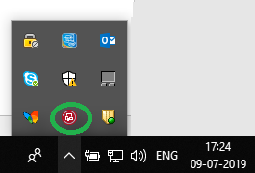
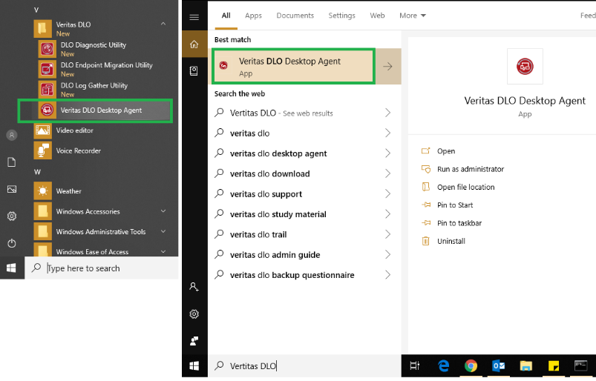
Please ensure to complete backup of files until VERITAS DLO agent confirmed that “Your files are protected when they change” and backup get completed 100% “as shown in the screen shot.
